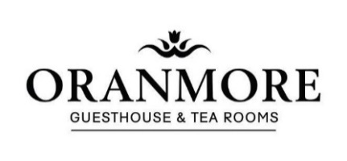

Sunday Evening Menu
Homemade Soup of The Day, Crusty Bread
Pearls Of Melon and Mandarins with Refreshing Sorbet
Garlic And Chilli Prawns, Crab Claws, Sourdough Bread, Seasonal Salad
Five Spiced Slow Roasted Duck Croquette, Spiced Mayonnaise, Pomegranate Dressing
Baked Goat’s Cheese, Sundried Tomato Tartlet
Prawn, Smoked Salmon, Oranmore Wheaten Bread
Parsnip Bhaji with Curry Oil served with Asian Slaw (V)

Mains
10oz Sirloin Steak, Portobello Mushroom, Confit Shallot with Pink Peppercorn Cream (£6.00 Supplement)
County Antrim Turkey, Honey Roast Ham with Parsley Stuffing, Gravy and Chipolata Sausages.
Slow Roast Silverside of Beef, Yorkshire Pudding, House Gravy.
Roast Leg of Lamb with Caramelized Peach, Mint Sauce, House gravy
Crispy Pork Belly with Glazed Pork Cheek, Apple Cider Cream, Savoy Cabbage
Ballotine of Stuffed Chicken wrapped in Streaky Bacon served with Honey Roast Parsnips, Leek and Mushroom Cream Sauce
Pan Fried Sea Trout, Wild Garlic Orzo Pasta, Wilted Greens and Sun-Dried Tomato Dressing
White Bean Cassoulet with Stuffed Peppers and a Roast Nut Crumb (V)
Desserts
Apple and Cinnamon Sponge served with Custard and Fresh Cream
Summer Berry Pavlova
Blueberry and Buttermilk Pannacotta with Homemade Shortbread
Sticky Toffee Pudding served with Vanilla Ice Cream
Butterscotch Ice-Cream Sundae
Strawberry Trifle
*Freshly Brewed Tea/Coffee *
Two Courses £42.50 Three Courses £47.50
Please make any dietary requirements known to your server

